

# Experiment No. 5

**Problem Statement:**

Intensity Transformations using python

**AIM:**

Write a Python Code for following Intensity Transformations:

1. Intensity Level Slicing Without Background
2. Intensity Level Slicing with Background
3. Log
4. Power Law

# Objective(s) of Experiment:

# To enhance the image intensity using level slicing, log and power law transformation

# Introduction:

# Intensity Level Slicing highlights the particular range of gray levels in an image. It handles a group of intensity levels in an image up to a specific range by reducing rest or by leaving them alone.

# Log transformation of an image means replacing all pixel values, present in the image, with its logarithmic values. Log transformation is used for image enhancement as it expands dark pixels of the image as compared to higher pixel values.

# Power – Law transformations is used for enhancing images for different type of display devices. The gamma of different display devices is different. For example, Gamma of CRT lies in between of 1.8 to 2.5, that means the image displayed on CRT is dark.

**Flowchart:**

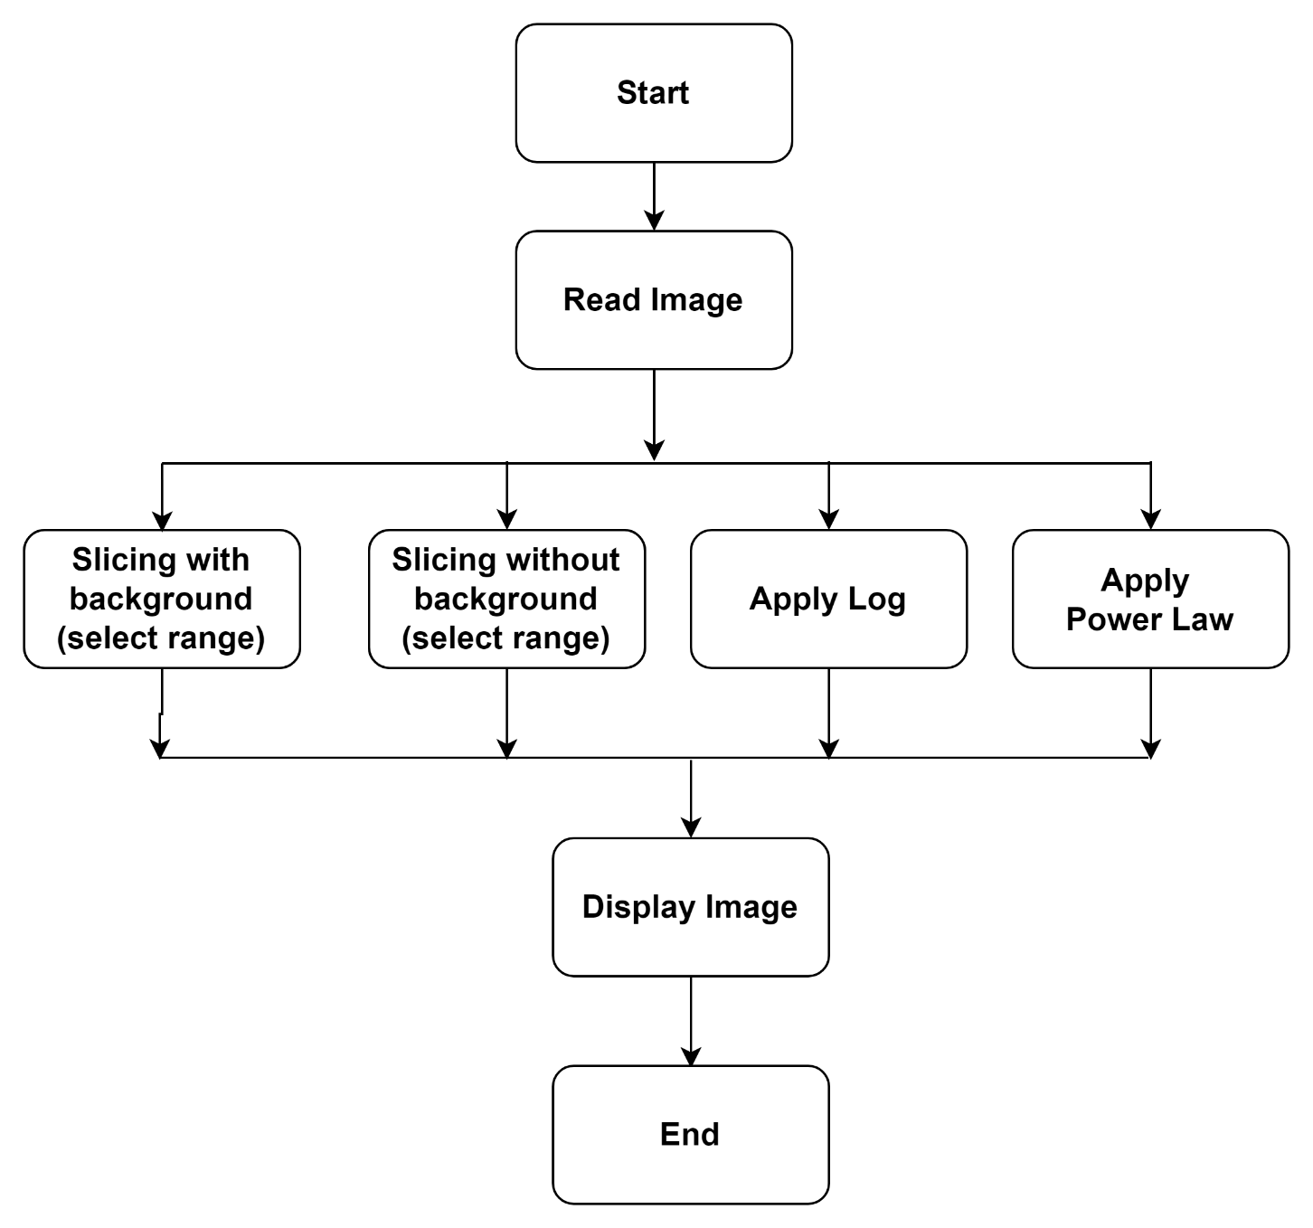

# Code and Results:

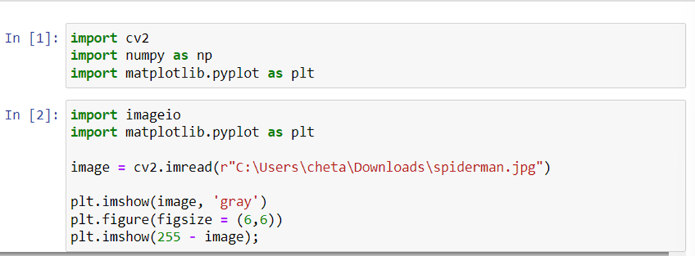

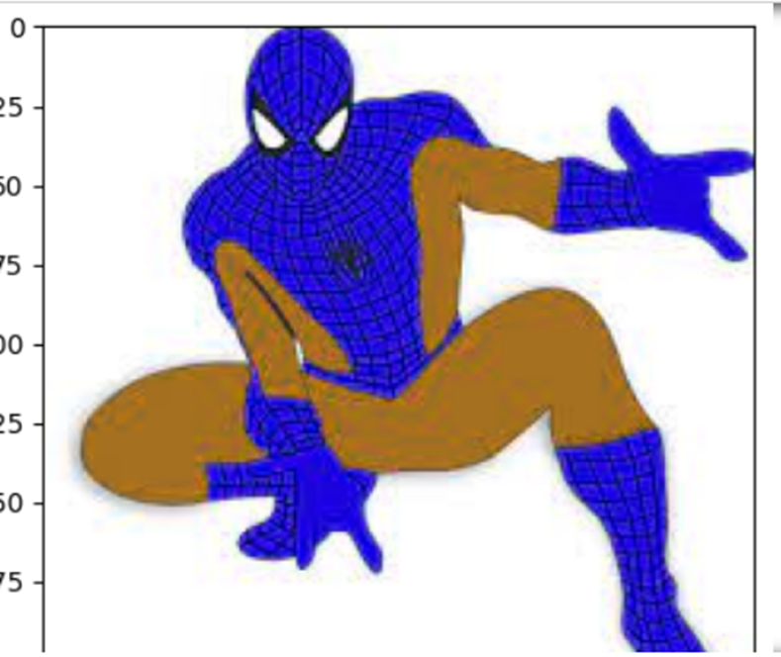

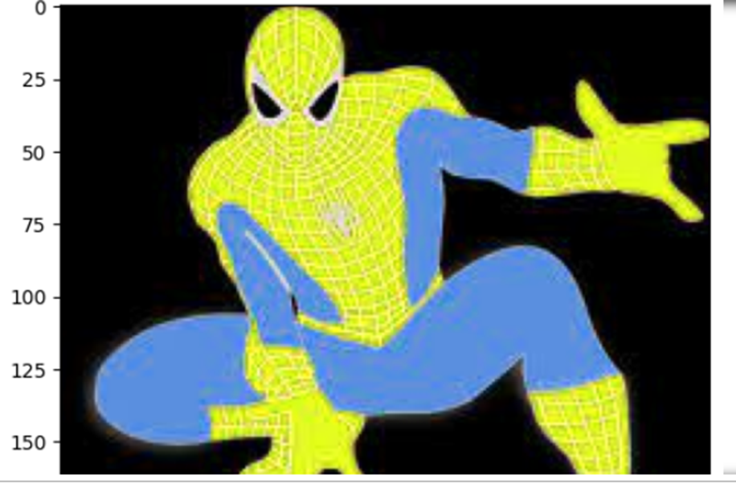

**Intensity Level Slicing without Background**

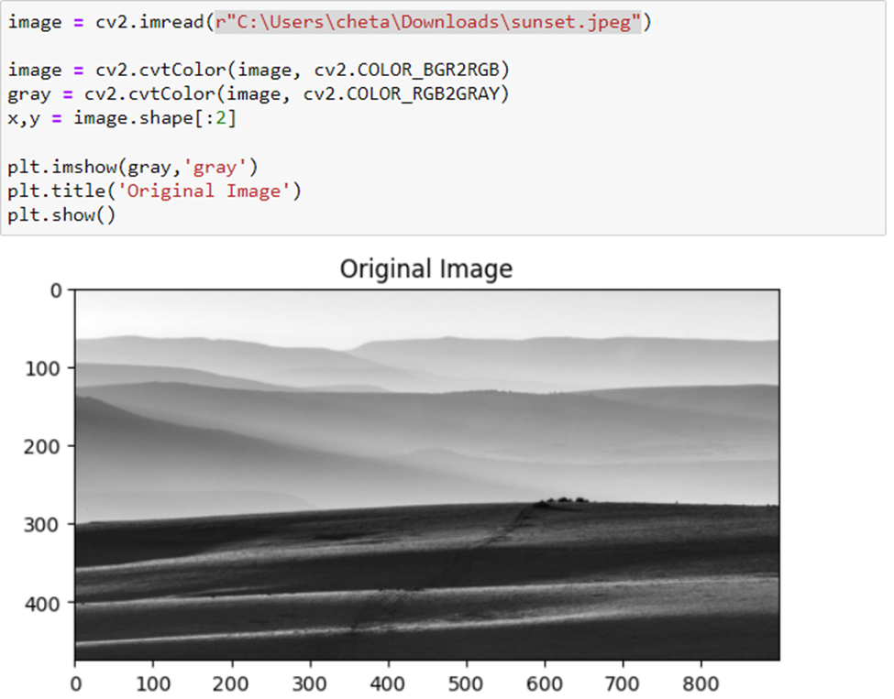

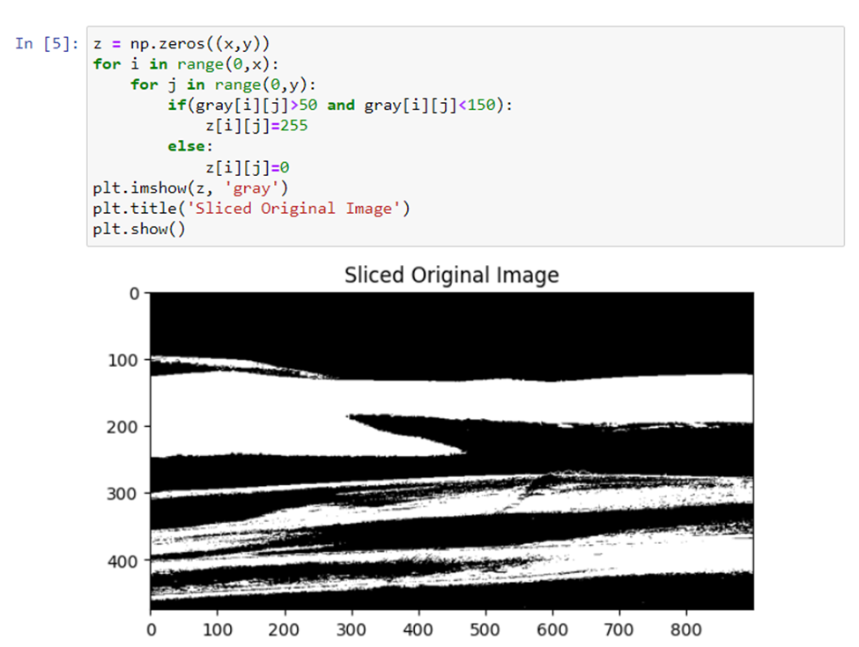

**Intensity Level Slicing without Background**

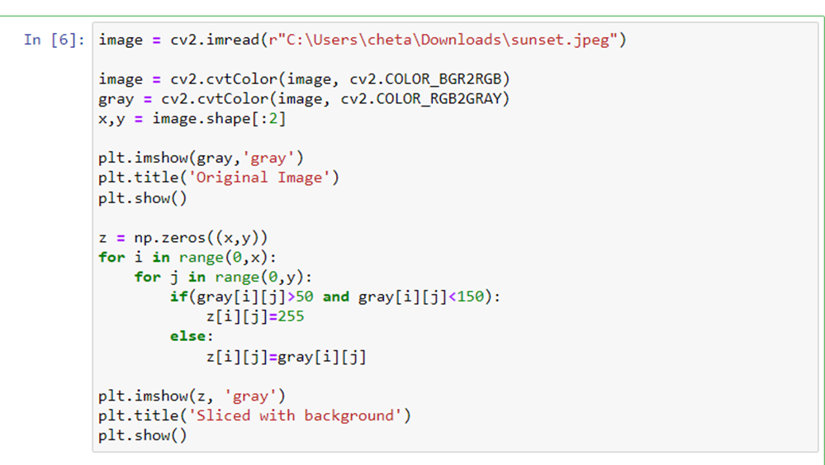

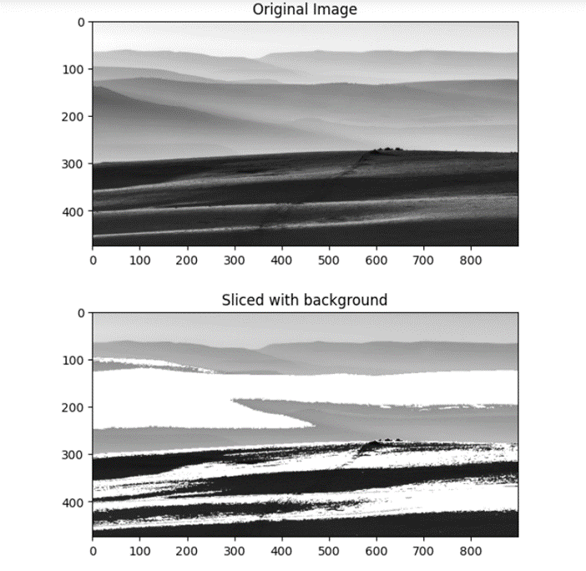

**Log transformation**

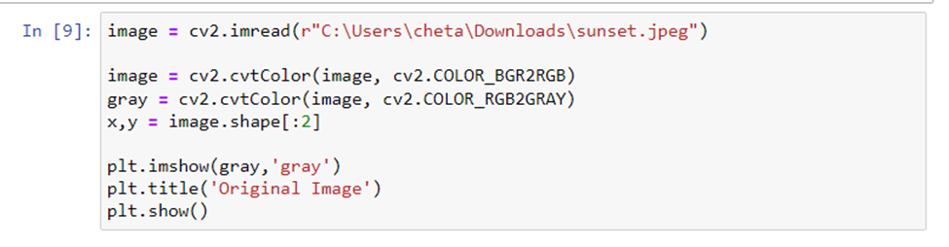

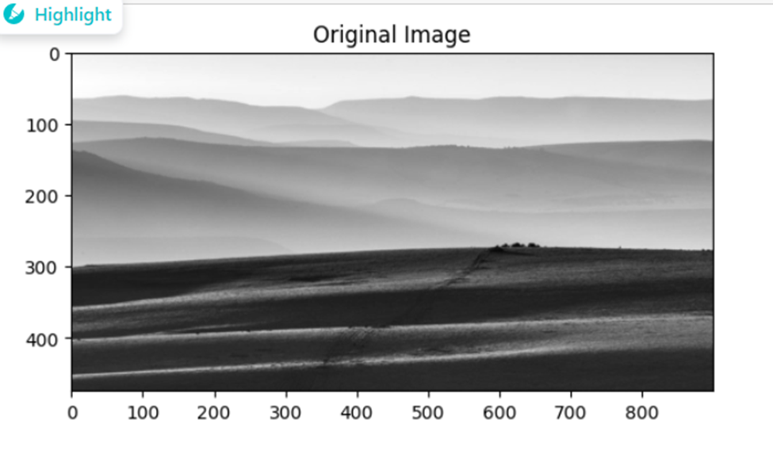

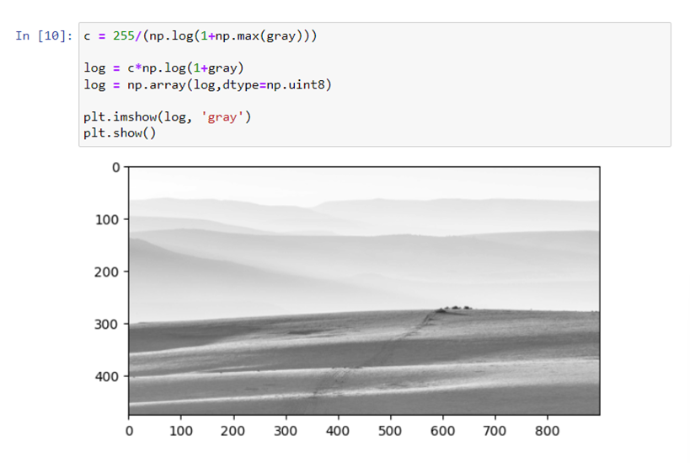

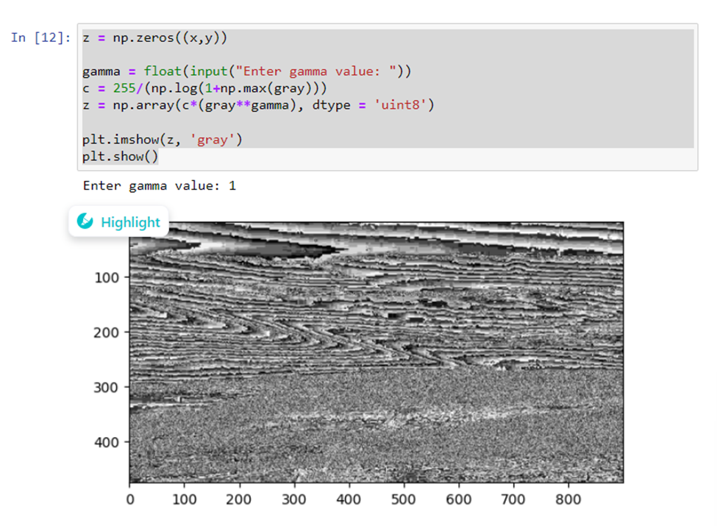

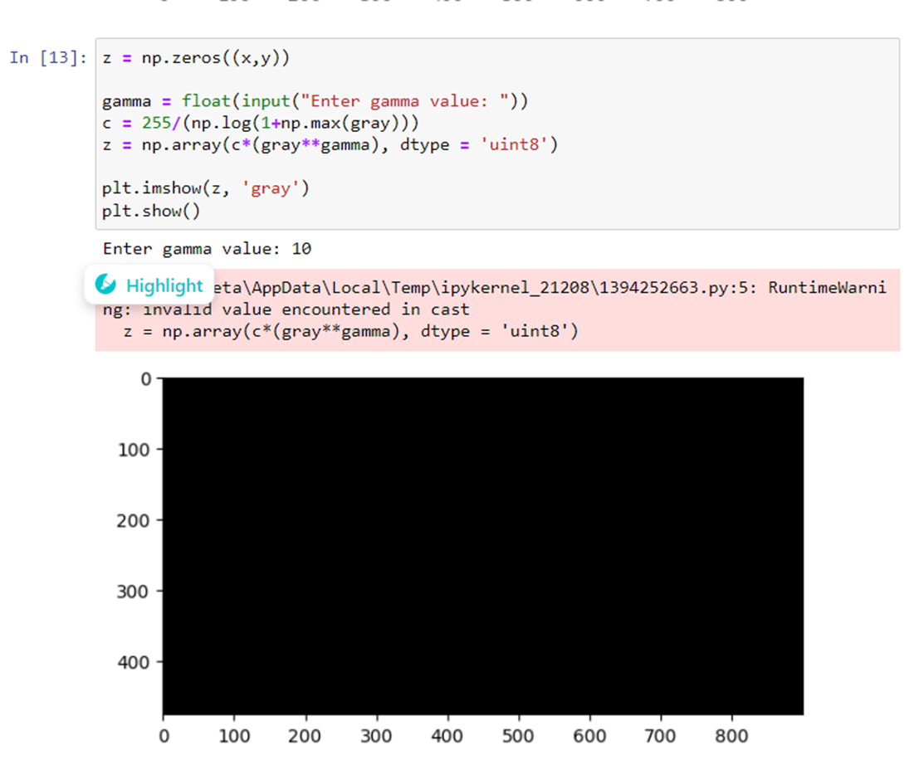

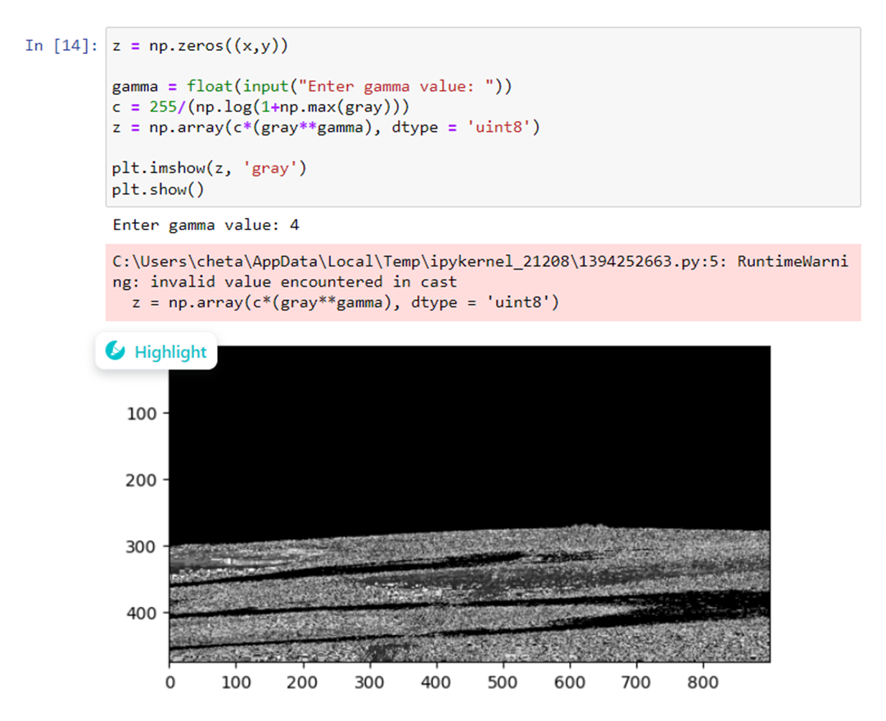

# Conclusions:

1. In negative image transformation we have just converted individual pixel intensity to 255-pixel intensity. In intensity level slicing without background after converting the image pixel intensity between 50 to 150 equals 255 and other pixel intensities to 0. We get a black-and-white image with intensities of 0 and 255 only.
2. In intensity slicing with the background we had only changed the pixel intensity in the range 50 to 150 equals 255 and pixel intensities other than this range remain as it is. Then we get the image gray scale image with some intensities of 255 and other intensities less 50 and greater than 150.
3. In power law transform as the value of gamma increases the output image became more black